**Netflix Dashboard Analysis For Business Growth And Decision-Making**

**1. Business Understanding**

The dataset represents Netflix titles, including details like type (Movie or TV Show), ratings, duration, release year, country, cast, and director. The primary goal appears to be analyzing the distribution and trends of Netflix content to support business decisions, such as understanding popular genres, optimal duration, preferred ratings, and country-based performance.

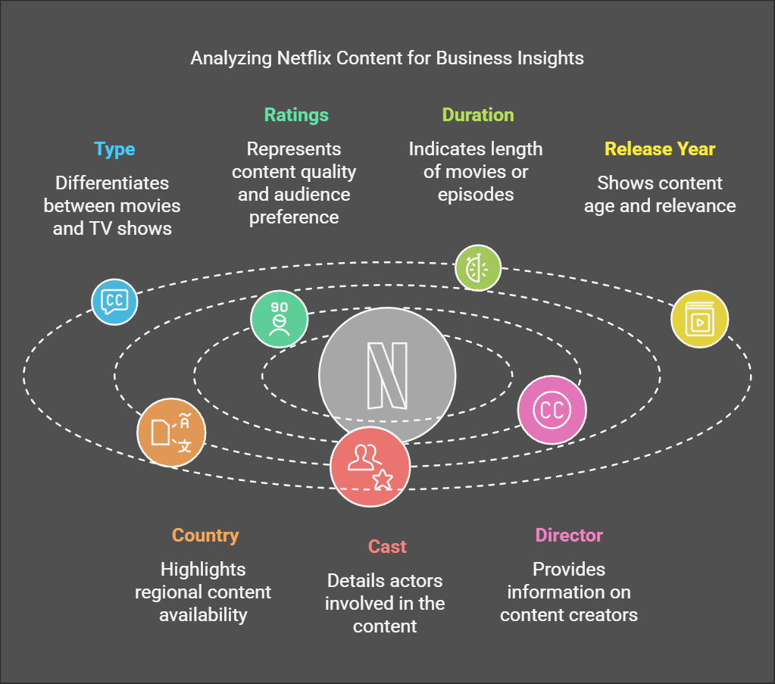

**2. Data Required**

To meet the business goals, the following data attributes are relevant:

* **Type**: Whether the content is a Movie or TV Show.
* **Country**: Countries of origin for the titles.
* **Release Year**: The years when the titles were released.
* **Rating**: Classification ratings like G, PG, R, etc.
* **Duration**: Runtime for Movies or number of seasons for TV Shows.
* **Cast and Director**: Individuals involved in the production.
* **Netflix Title Count**: Total titles available in each category.

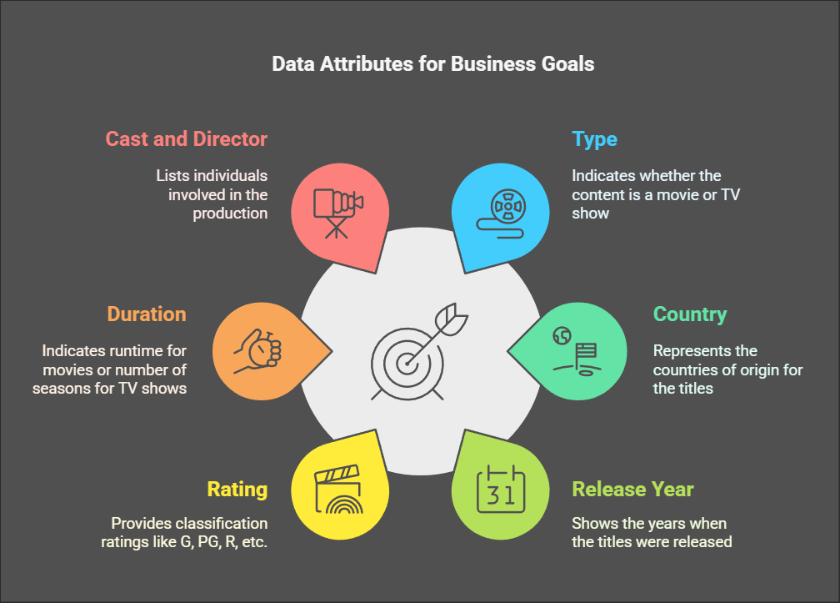

**3. Data Collection**

The data appears to have been sourced from Netflix's library or a similar repository, focusing on metadata about titles. Data was likely compiled via Netflix's API or a publicly available dataset.

**4. Data Validation and Understanding**

* **Structure**: The dataset includes categorical (e.g., Type, Country) and numerical data (e.g., Duration, Release Year).
* **Distribution**: The dashboard shows visual distributions for Type vs. Netflix count, Release Year vs. Rating, and Country vs. Type.
* **Missing Data**: Some fields like "Country," "Director," and "Rating" have null values, which need addressing for accurate analysis.

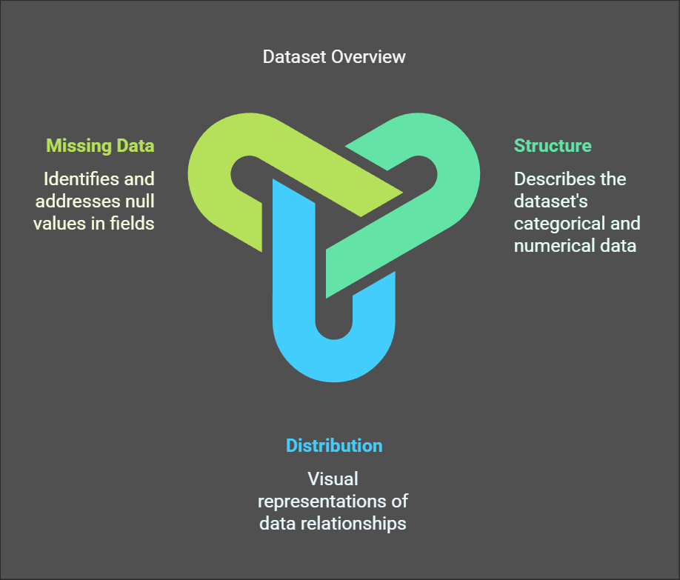

**5. Data Cleaning**

* **Handle Missing Values**: Impute missing values using logical approaches like replacing "Country" nulls with "Unknown" or the most frequent value, and dropping or imputing ratings with mode/median.
* **Standardize Durations**: Ensure all durations (minutes or seasons) are consistent.
* **Remove Duplicates**: Check for duplicate entries and remove them.
* **Filter Data**: Focus on years and types relevant to analysis (e.g., exclude very old or irrelevant entries).

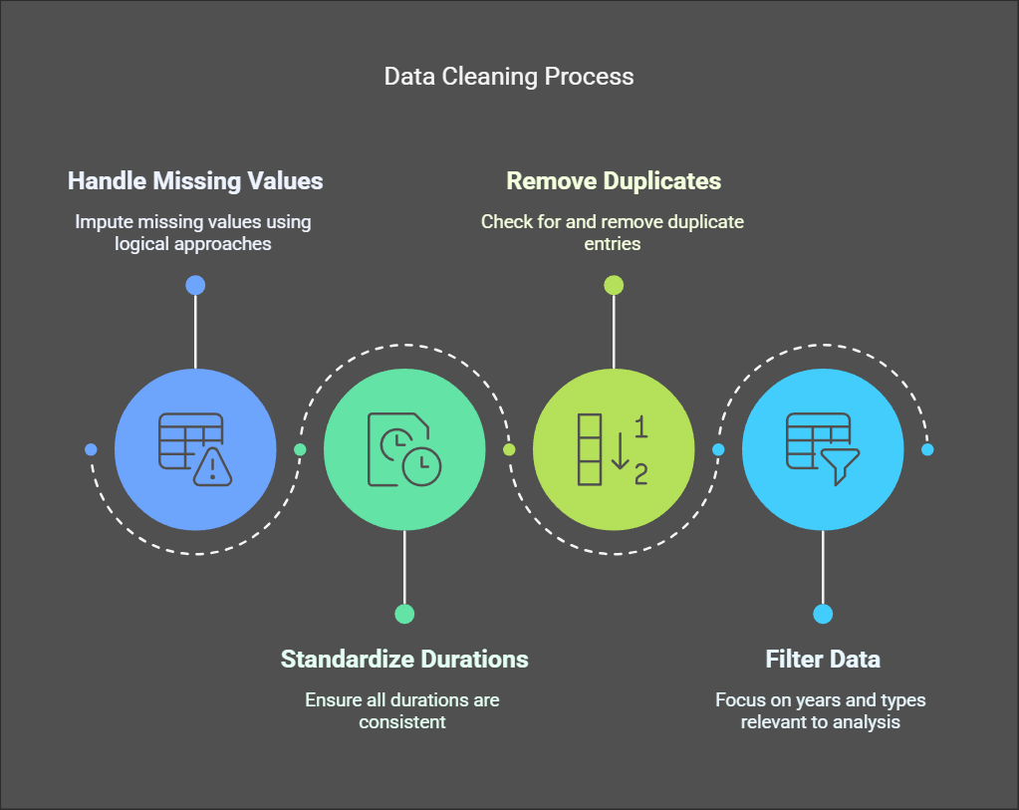

**6. Data Analysis Using Different Tools**

Key analysis performed:

* **Type vs. Netflix Count**: Movies dominate the Netflix catalog compared to TV Shows.
* **Release Year vs. Rating**: Most content is from recent years, with a noticeable spike in specific ratings like "TV-MA" and "R."
* **Country vs. Type**: Countries like the U.S., South Korea, and India lead content production. However, some countries appear underrepresented or null.
* **Duration Trends**: The dashboard identifies the average runtime for movies and the number of seasons for TV Shows.

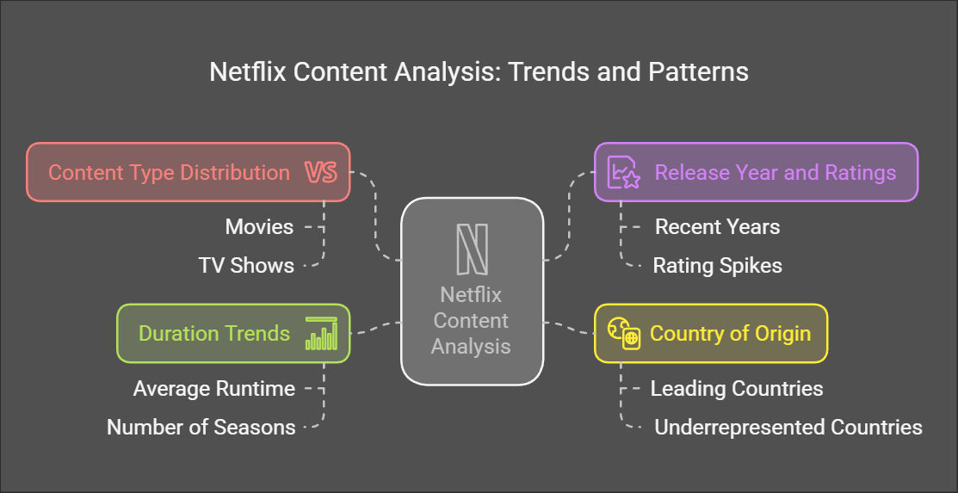

**7. Dashboard Preparation**

The dashboard consolidates findings into charts:

* **Bar Graphs**: Netflix title count by Type.
* **Line Chart**: Trends for Release Year vs. Ratings.
* **Scatter Plots**: Relationships between Netflix titles, ratings, and duration.
* **Country Map**: Geographical distribution of content by Type.

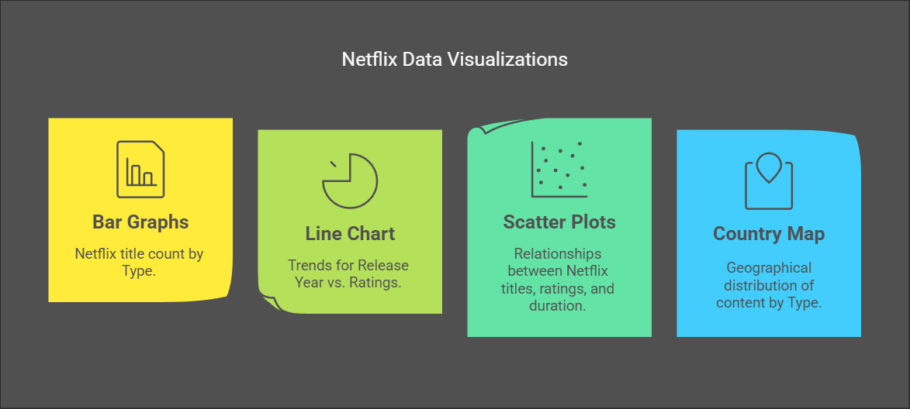

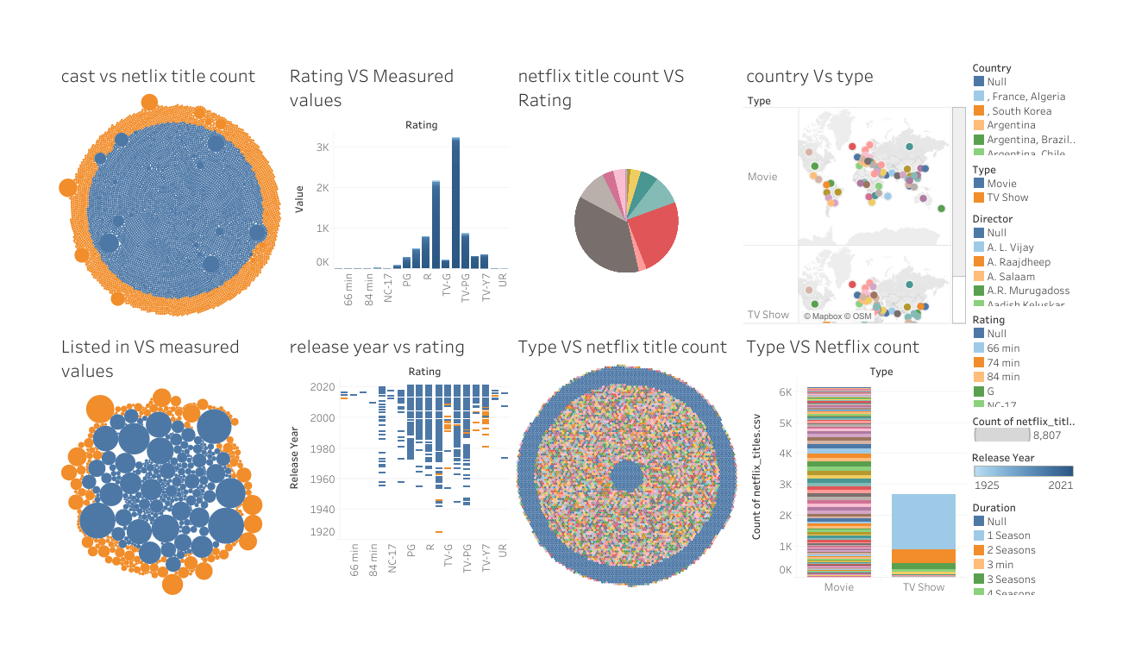

**8. Meaningful Information**

From the dashboard:

* **Content Diversity**: Netflix predominantly offers Movies, with a large number of titles released in recent years.
* **Preferred Ratings**: PG-13 and TV-MA dominate, hinting at a focus on broader audiences and mature content.
* **Regional Focus**: Key contributors include the U.S., India, and South Korea. Lesser representation from African and smaller European countries might indicate potential areas for content acquisition.
* **Duration Optimization**: Movies around 90-120 minutes and TV Shows with 1-2 seasons perform better in terms of availability.

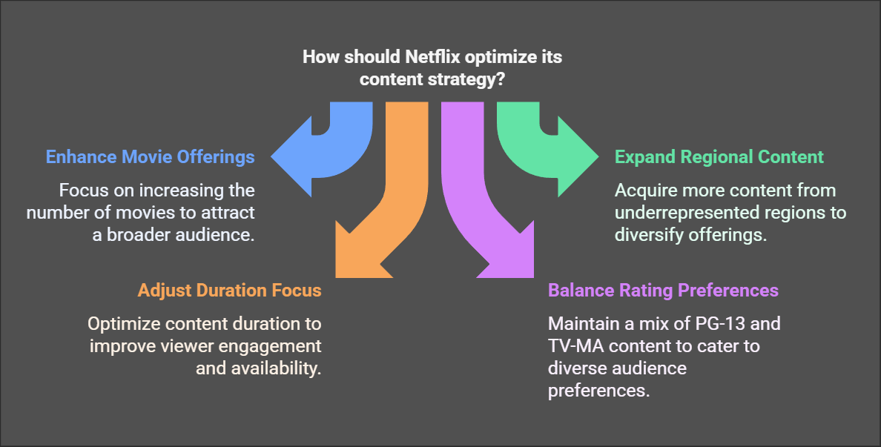

**9. Decision and Business Growth**

* **Content Acquisition**: Increase titles from underrepresented regions to cater to a more global audience.
* **Audience Focus**: Expand in-demand categories like TV-MA and PG-13 while maintaining family-friendly content.
* **Shorter Content**: Invest in shorter-duration movies and mini-series as they are easier to consume and perform better.
* **Partnerships**: Collaborate with emerging directors and countries with growing interest in streaming platforms.

